AICTE Internship Registration Process:
For general registration:
Step 1: Visit http://www.aicteinternships.in/
Step 2: Click “Register” button on the top right corner of the page
Step 3: Select who you are

For Student Registration:
Step 4: Click on “I AM STUDENT!” Browse Internships button
Step 5: Fill in your details in the “Student Registration” page and Click on “Register” button
Step 6: Enter the OTP received via SMS or Mail for verification and click on “Verify” button
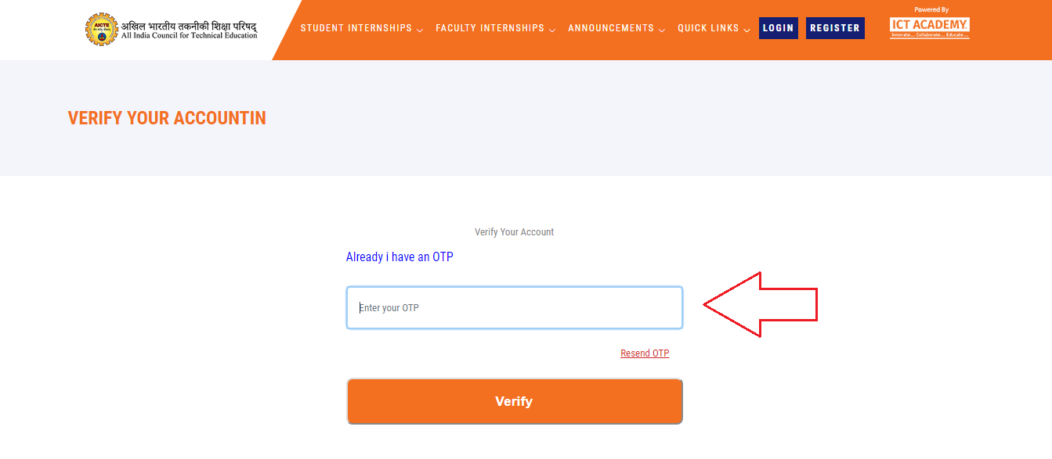
Step 7: Then you will be redirected to “Log in” page
Step 8: Enter the email address and password and click on “Login” button
Step 9: You will be entering your dashboard where you can search, view and apply for internships available in the portal

For Faculty Registration:
Step 4: Click on “I AM FACULTY!” Browse Internships button
Step 5: Fill in your details in the “Faculty Registration” page and Click on “Register” button
Step 6: Enter the OTP received via SMS or Mail for verification and click on “Verify” button
Step 7: Then you will be redirected to “Log in” page
Step 8: Enter the email address and password and click on “Login” button
Step 9: You will be entering your dashboard where you can search, view and apply for internships available in the portal

For Corporate Registration:
Step 4: Click on “I AM CORPORATE!” Post Internships button
Step 5: Fill in your details in the “Corporate Registration” page and Click on “Register” button
Step 6: Enter the OTP received via SMS or Mail for verification and click on “Verify” button
Step 7: Then you will be redirected to “Log in” page
Step 8: Enter the email address and password and click on “Login” button
Step 9: You will be entering your dashboard where you can search, view and apply for internships available in the portal

